VZORY
https://www.alibaba.com/product-detail/High-quality-handmade-rigid-jewelry-packing_60574331479.html?spm=a2700.7724838.0.0.eQYyCa
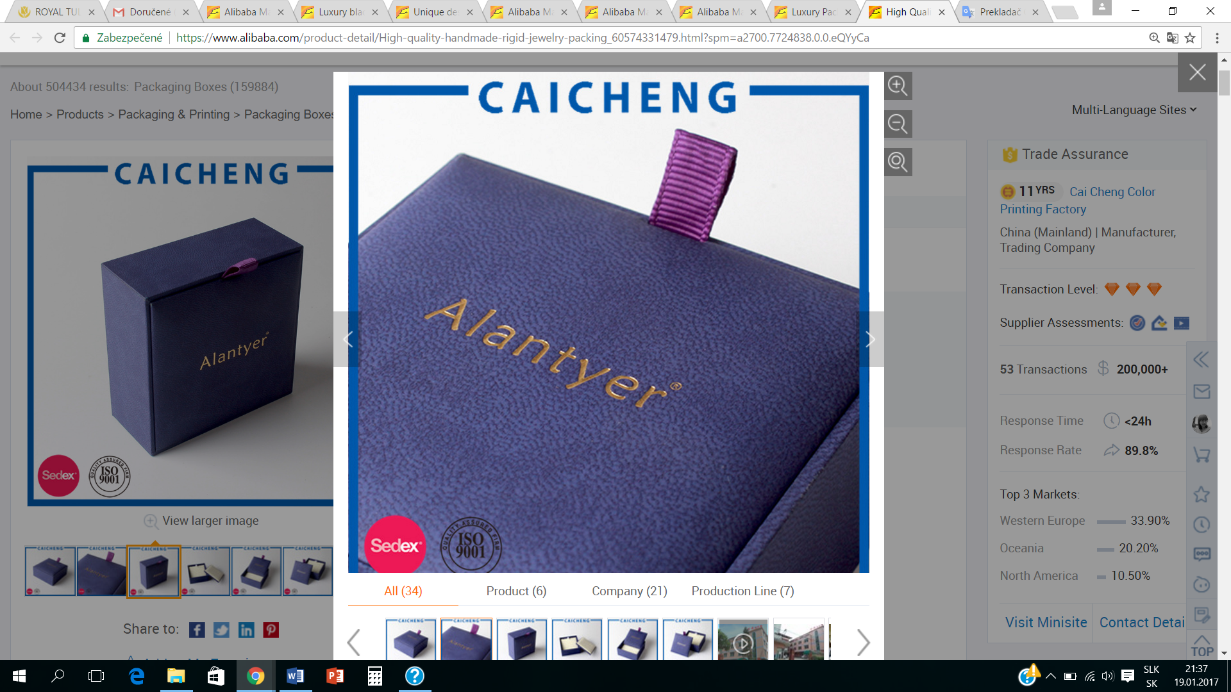

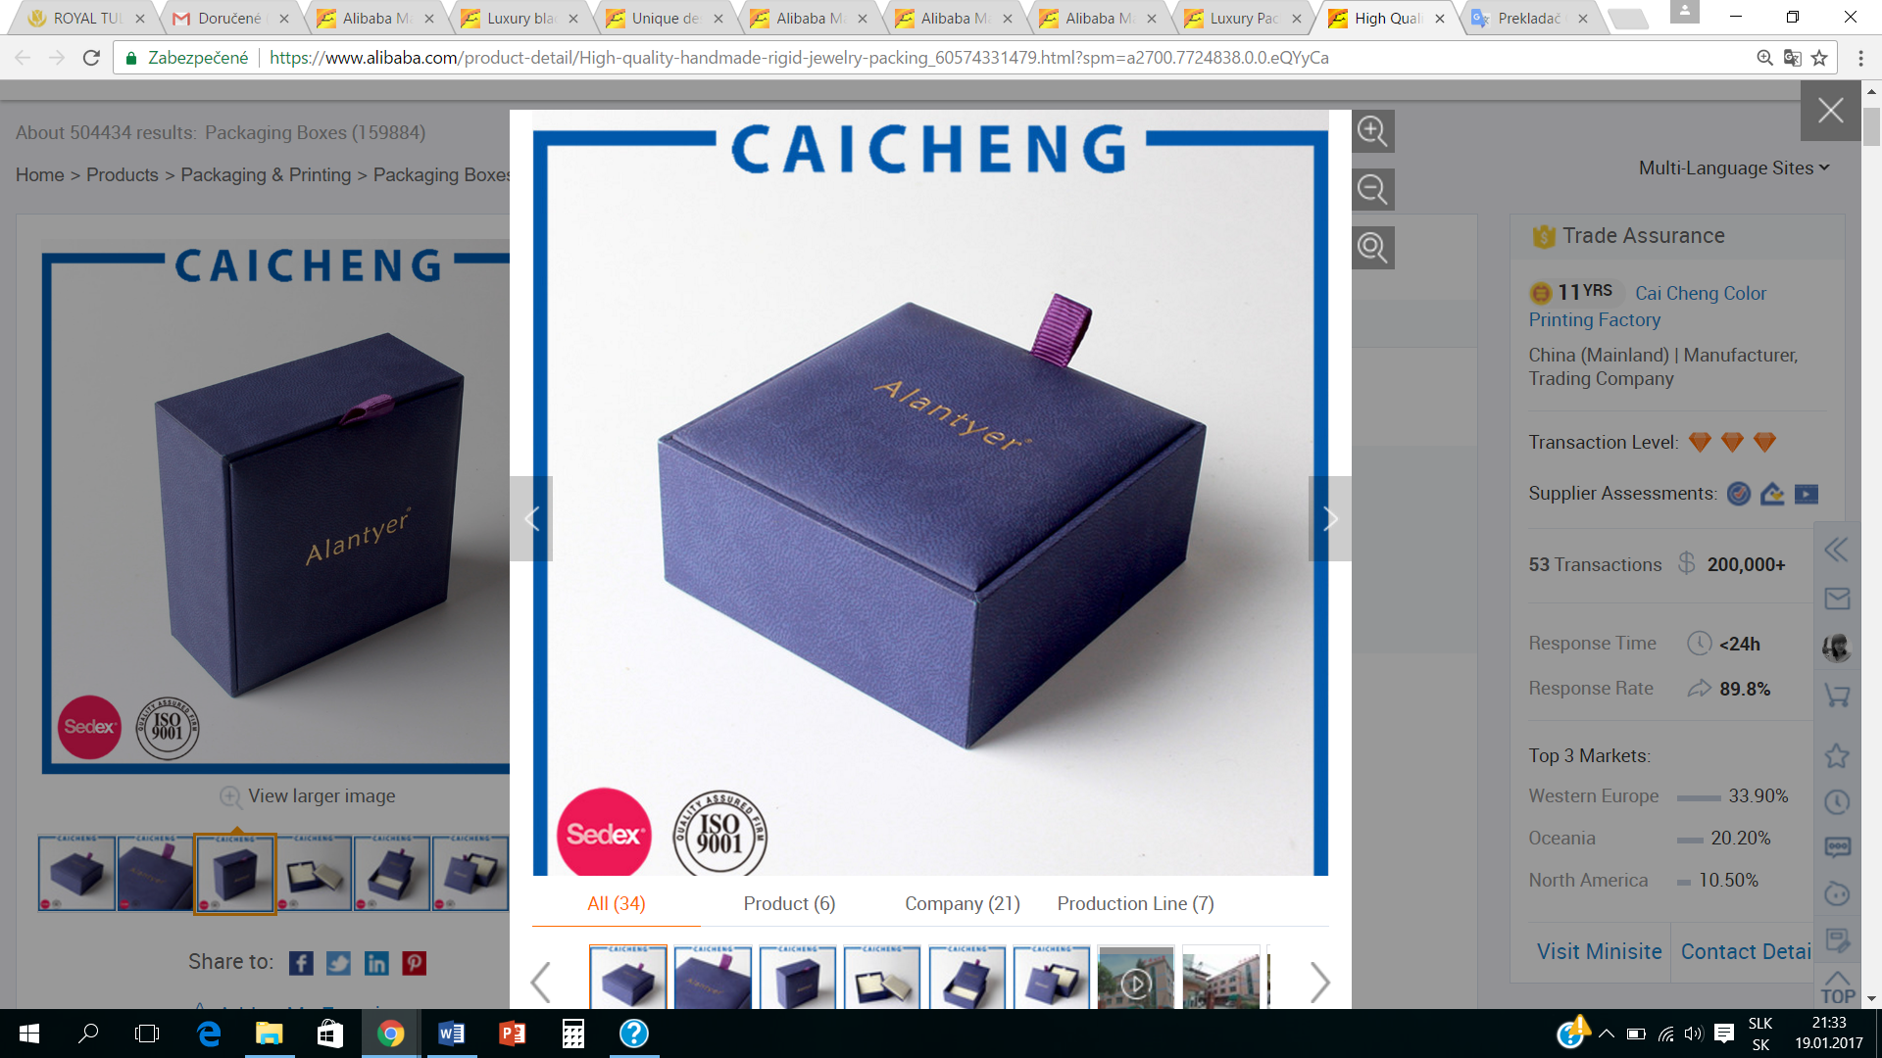

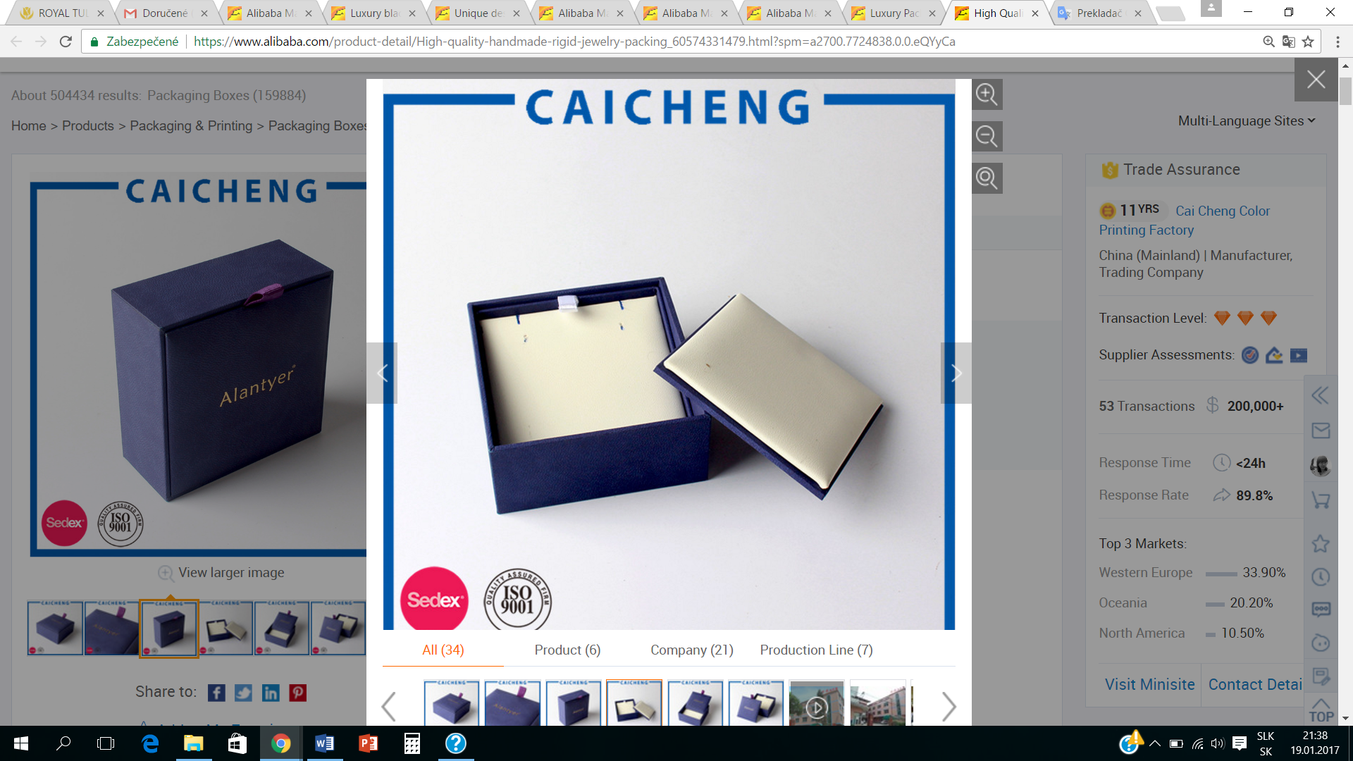
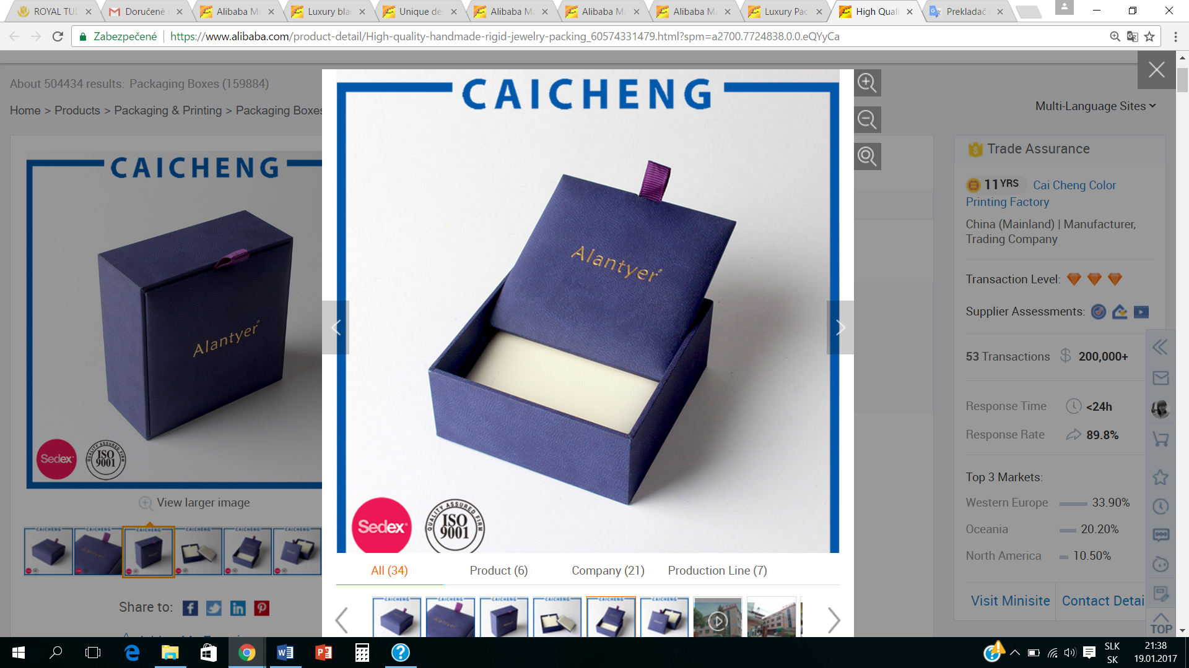
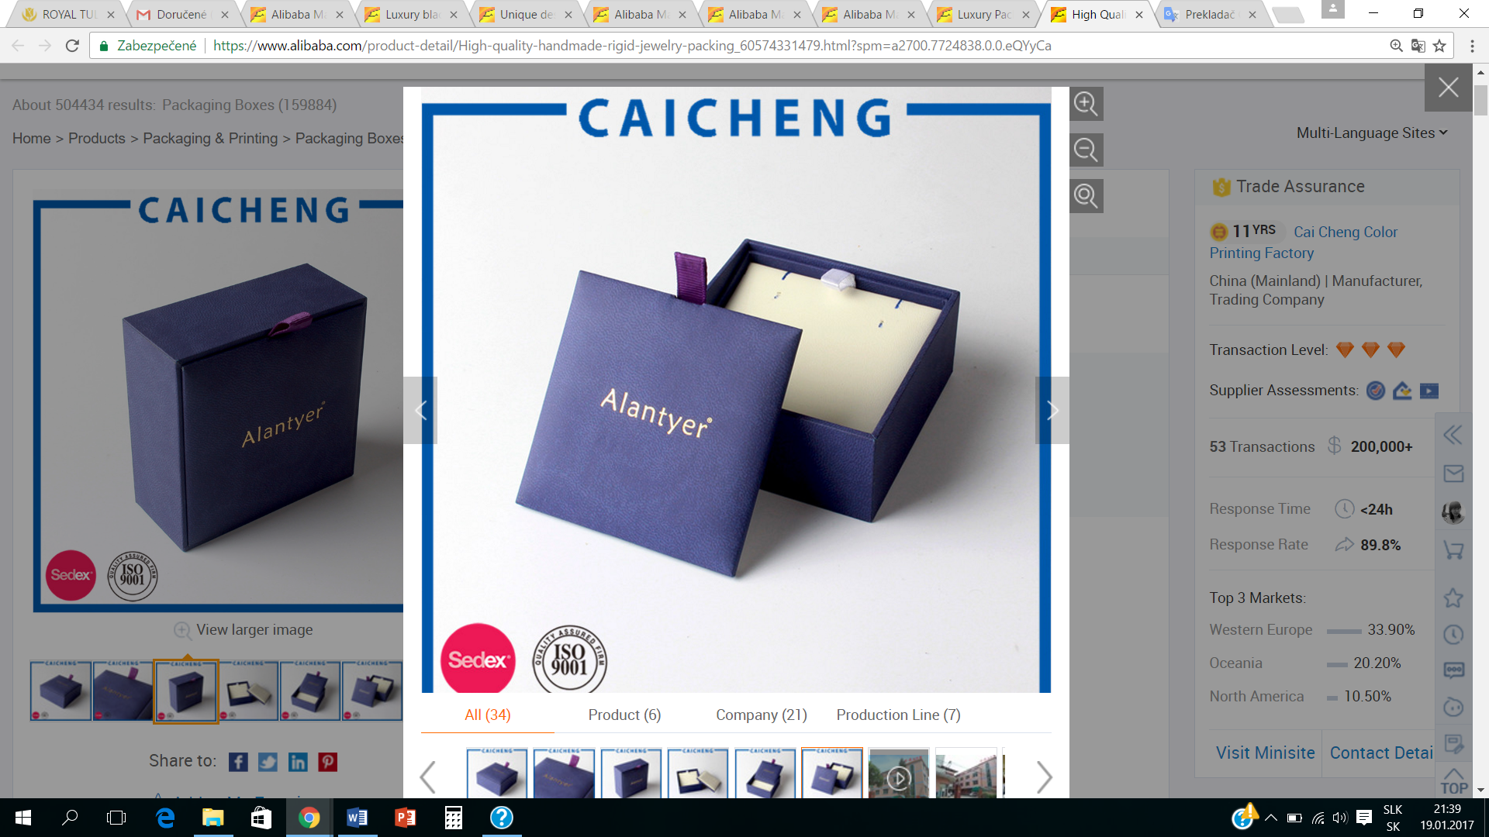

http://www.vancleefarpels.com/ww/en.html
https://www.google.sk/search?q=original+box+for+jewelry&espv=2&biw=1396&bih=690&source=lnms&tbm=isch&sa=X&ved=0ahUKEwiw8P_01dbRAhXoNpoKHXoUAEcQ_AUIBigB#imgrc=RQ8KLMZqorwq9M%3A
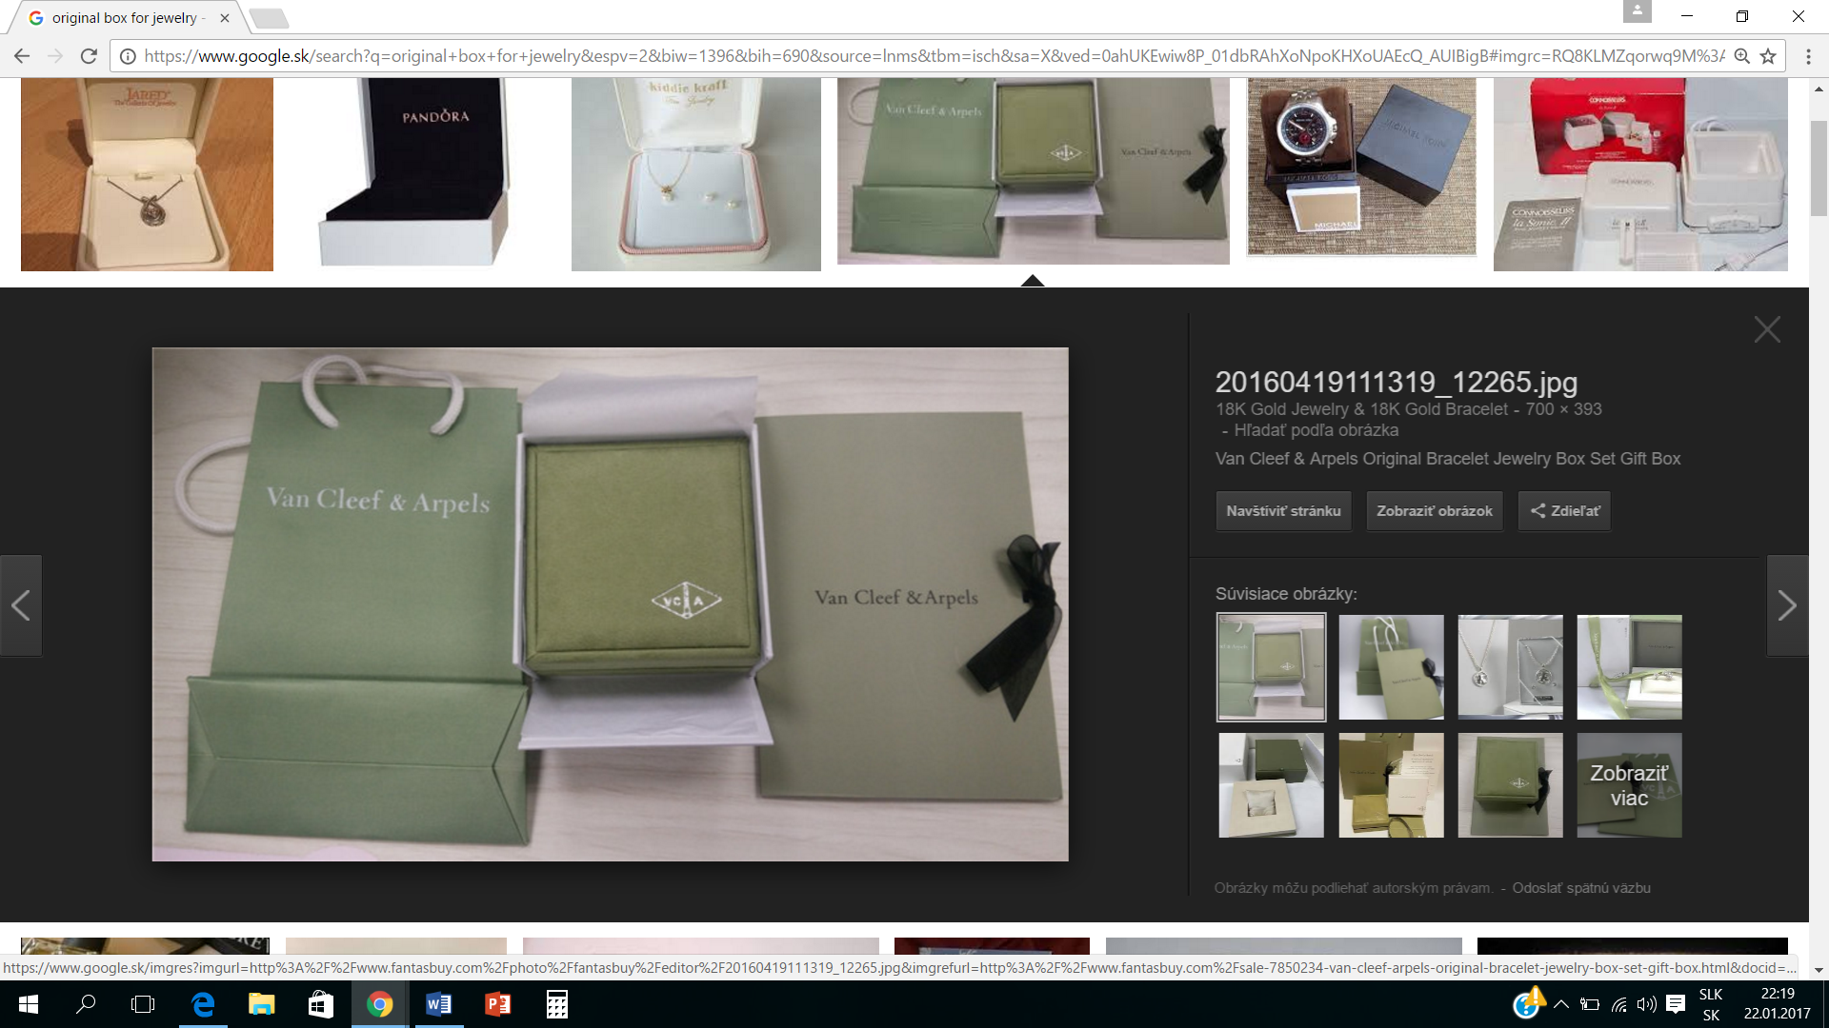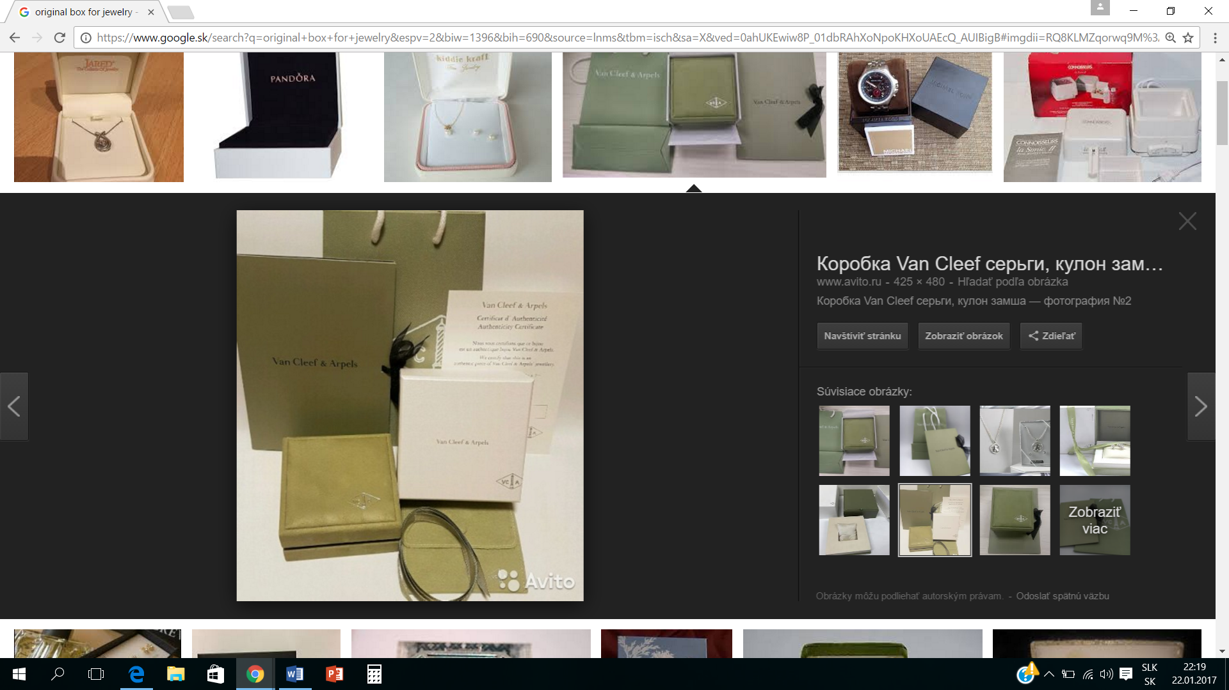

https://www.google.sk/search?q=original+box+for+jewelry&espv=2&biw=1396&bih=690&source=lnms&tbm=isch&sa=X&ved=0ahUKEwiw8P_01dbRAhXoNpoKHXoUAEcQ_AUIBigB#imgdii=xHE1CRhGst9a4M%3A%3BxHE1CRhGst9a4M%3A%3Bs_Np41rKDD2N5M%3A&imgrc=xHE1CRhGst9a4M%3A

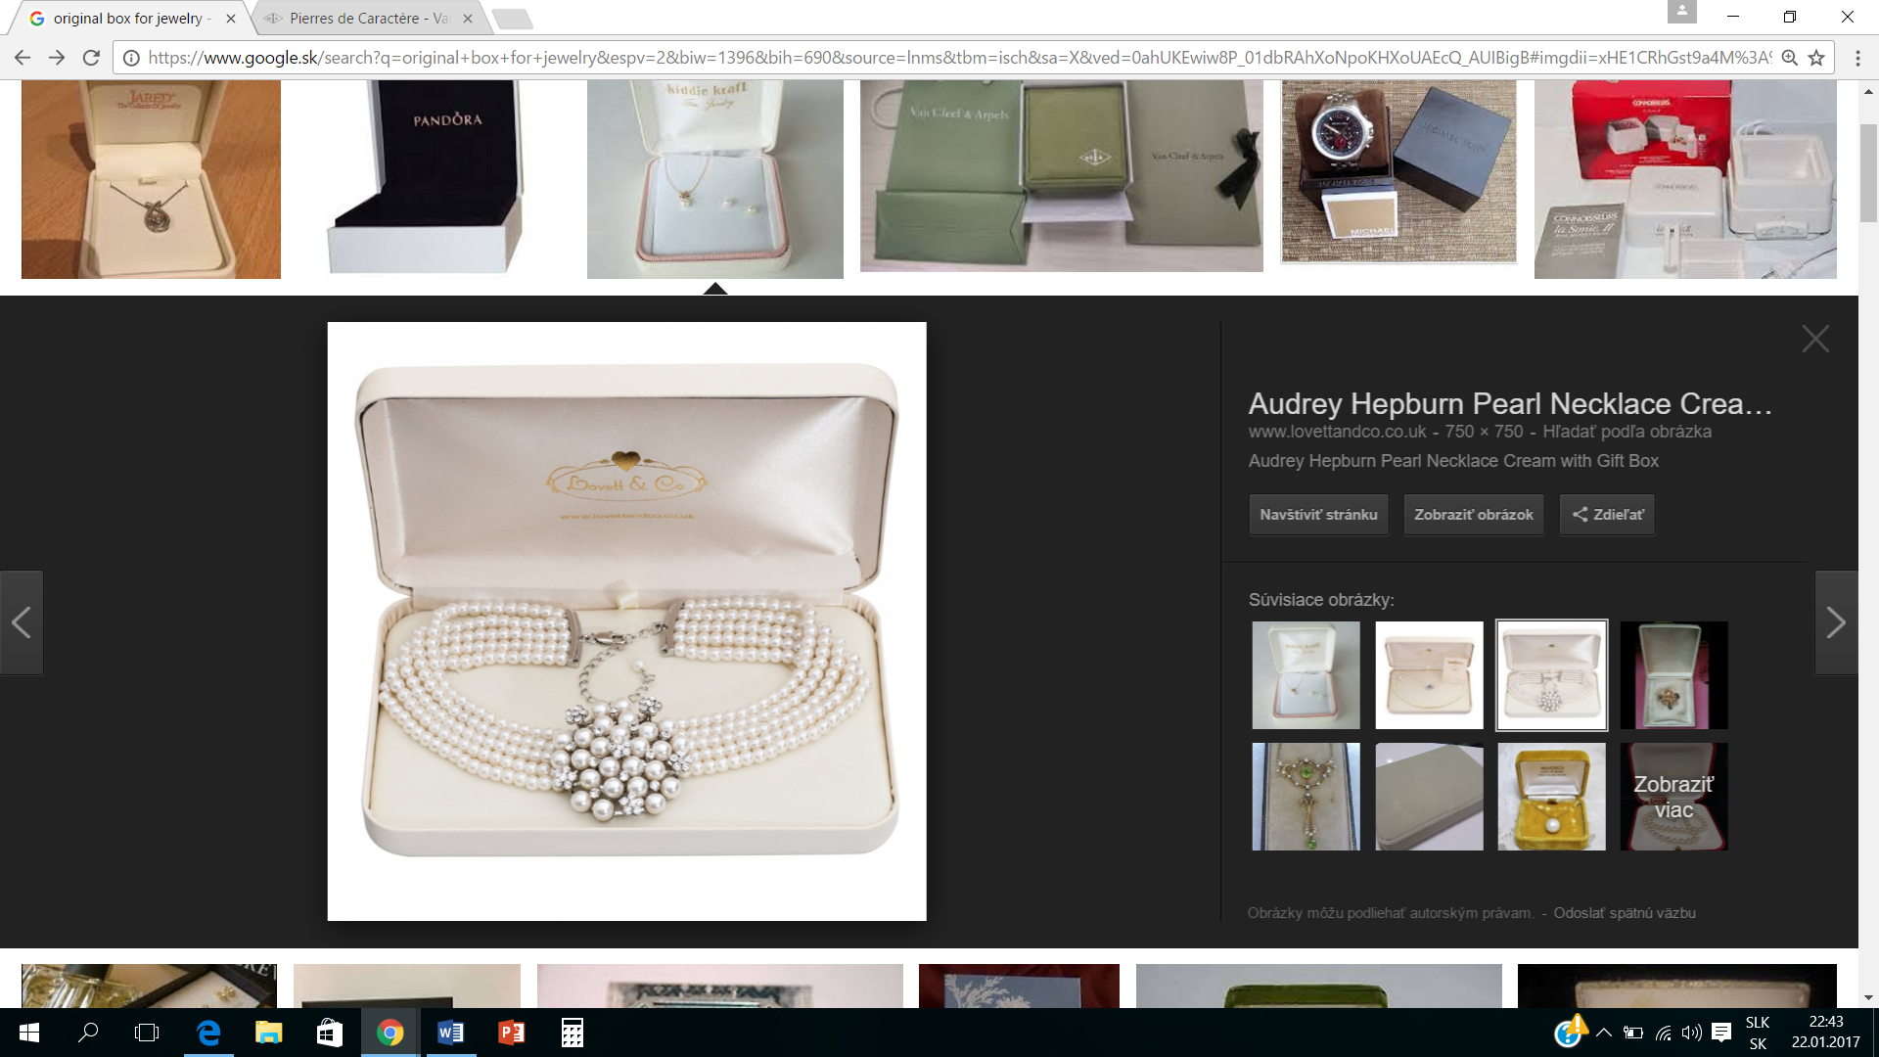

https://www.alibaba.com/product-detail/custom-made-cardboard-luxury-clothing-packaging_60483609066.html?spm=a2700.7724838.0.0.eQYyCa

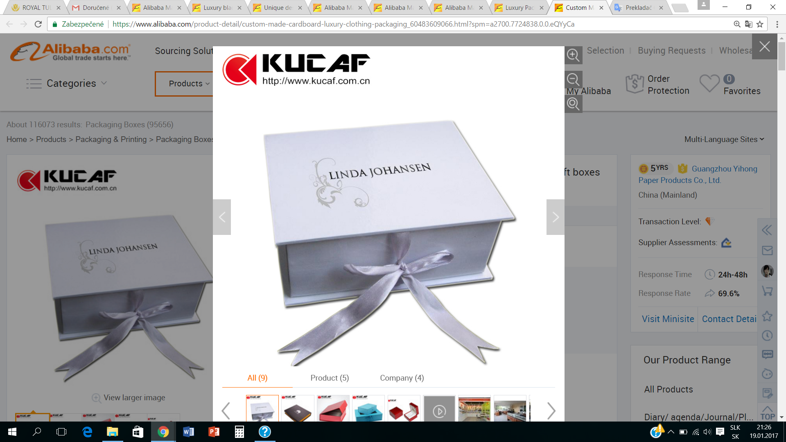

http://en.09635.com/pd/4818505/Jewelry-Packaging-Paper-Box-with-Special-Design-PB42-5-.htm#divContact
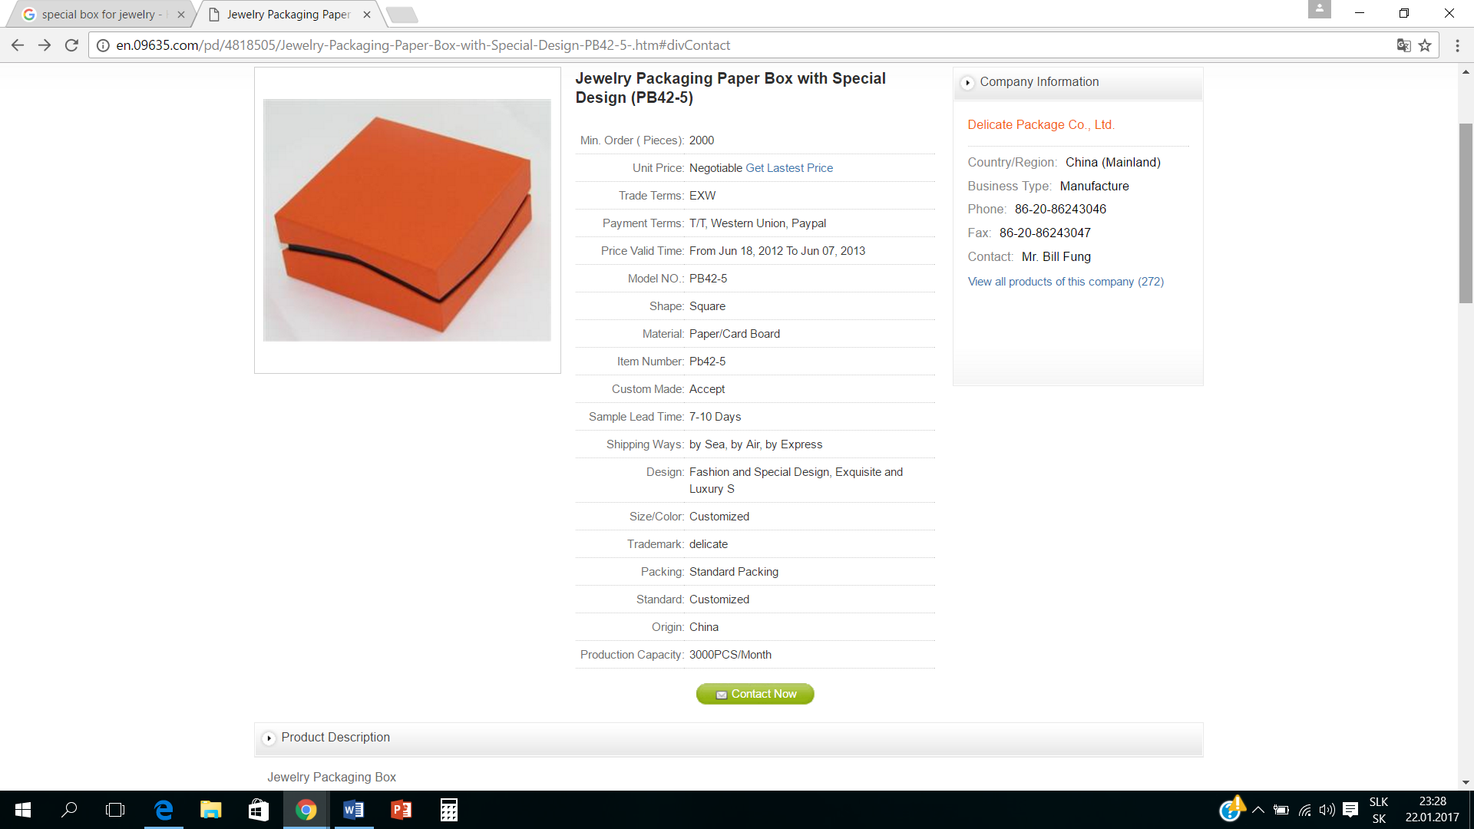
https://www.google.sk/search?q=special+box+for+jewelry&espv=2&biw=1396&bih=690&source=lnms&tbm=isch&sa=X&ved=0ahUKEwjsu_qz5dbRAhWGkSwKHTUeDtAQ_AUIBigB&dpr=1.38#q=special+box+for+jewelry&tbm=isch&tbs=rimg:CYgcyL0KwoU4IjjUm6WXAhpJDwkmtNw5nGoLV-0FBbv3NuiQHTeYIQpnK5AjkSk0N9o4fBuggdiKm7_1t1RALfXN_1ISoSCdSbpZcCGkkPEYEIP0AvbbDTKhIJCSa03DmcagsR1ufRxupJyv4qEglX7QUFu_1c26BHn_1xEniJMAwSoSCZAdN5ghCmcrEfwoMPgjKWukKhIJkCORKTQ32jgRlm1tYok3po4qEgl8G6CB2IqbvxFM6NaoSkrE4ioSCe3VEAt9c38hEQdA1C1_1RPBT&imgrc=iBzIvQrChTjOWM%3A

https://www.aliexpress.com/item/Luxury-Cufflinks-Box-High-Quality-Wooden-Box-Display-for-Personal-and-Best-Gift-for-Man/32782349868.html?spm=2114.01010208.3.61.KYKWaC&ws_ab_test=searchweb0_0,searchweb201602_4_10065_10068_10501_10503_10000032_10000025_10000029_430_10000028_10060_10062_10056_503_10055_10054_10059_10099_501_10000022_10000012_10103_10102_10000015_10096_10000018_10000019_10052_10053_10107_10050_10106_10051_10000007_10084_10083_10080_10082_10081_10110_10111_10112_10113_10114_10115_10000041_10000044_10078_10079_10000038_429_10073_10000035-10503_10501,searchweb201603_9,afswitch_3,single_sort_1_default&btsid=e24b284b-8971-4f94-b03a-81ab8b79ce50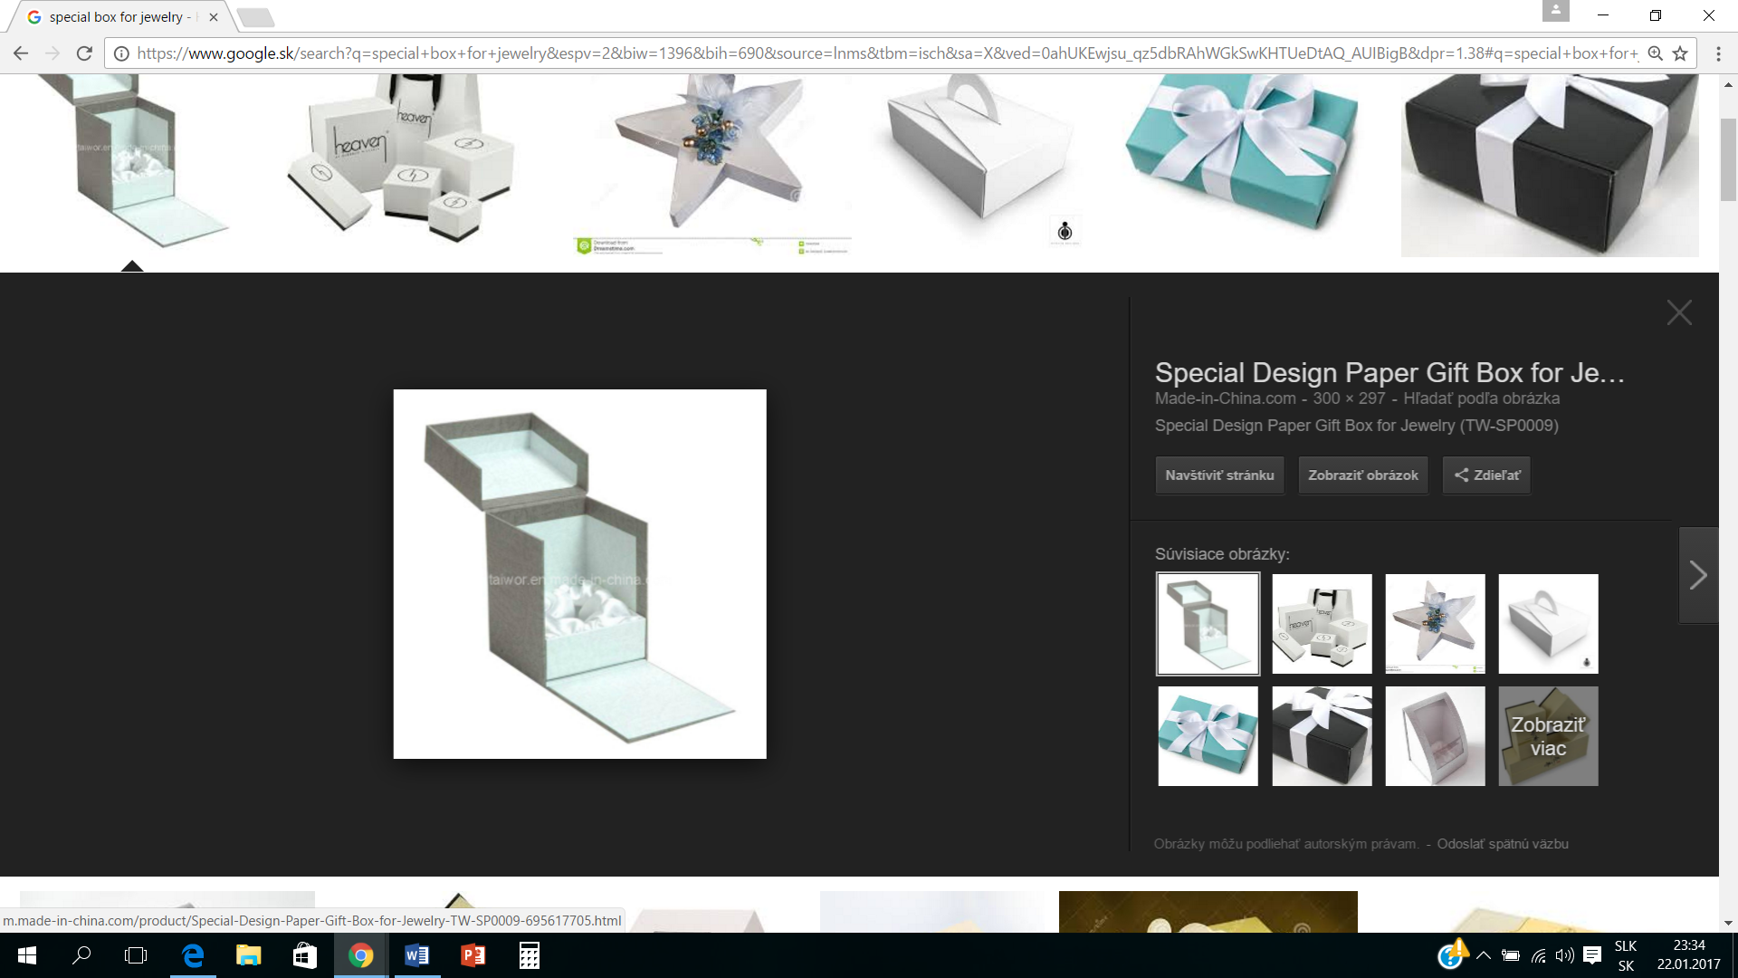
https://www.aliexpress.com/item/Luxury-Cufflinks-Box-High-Quality-Wooden-Box-Display-for-Personal-and-Best-Gift-for-Man/32782349868.html?spm=2114.01010208.3.61.KYKWaC&ws_ab_test=searchweb0_0,searchweb201602_4_10065_10068_10501_10503_10000032_10000025_10000029_430_10000028_10060_10062_10056_503_10055_10054_10059_10099_501_10000022_10000012_10103_10102_10000015_10096_10000018_10000019_10052_10053_10107_10050_10106_10051_10000007_10084_10083_10080_10082_10081_10110_10111_10112_10113_10114_10115_10000041_10000044_10078_10079_10000038_429_10073_10000035-10503_10501,searchweb201603_9,afswitch_3,single_sort_1_default&btsid=e24b284b-8971-4f94-b03a-81ab8b79ce50

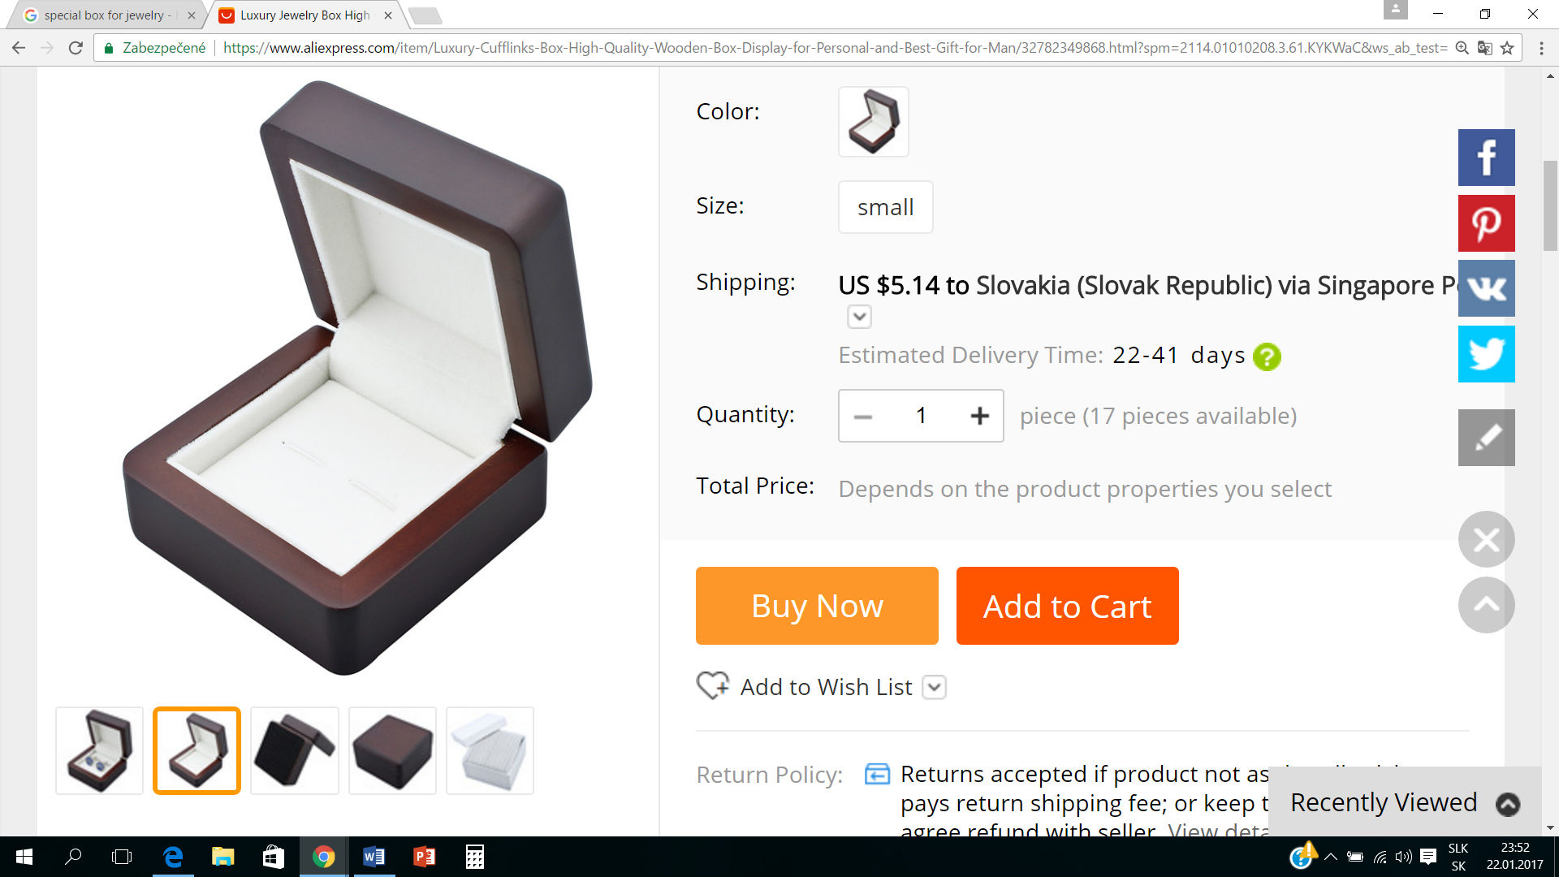
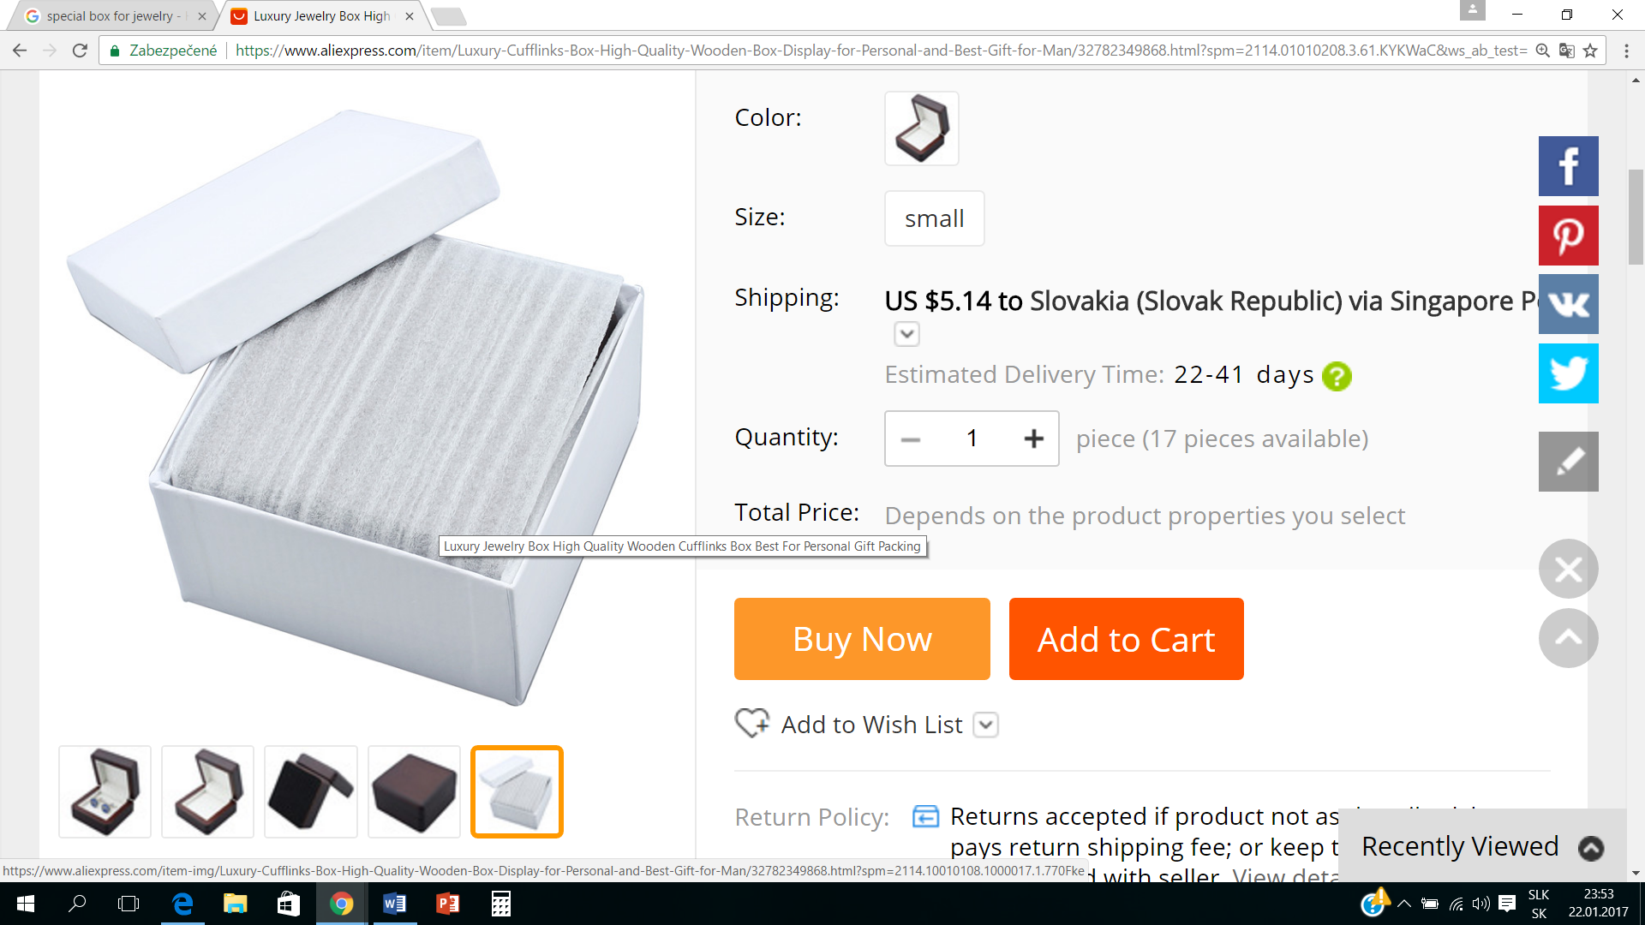

https://www.pinterest.com/pin/353251164495075055/

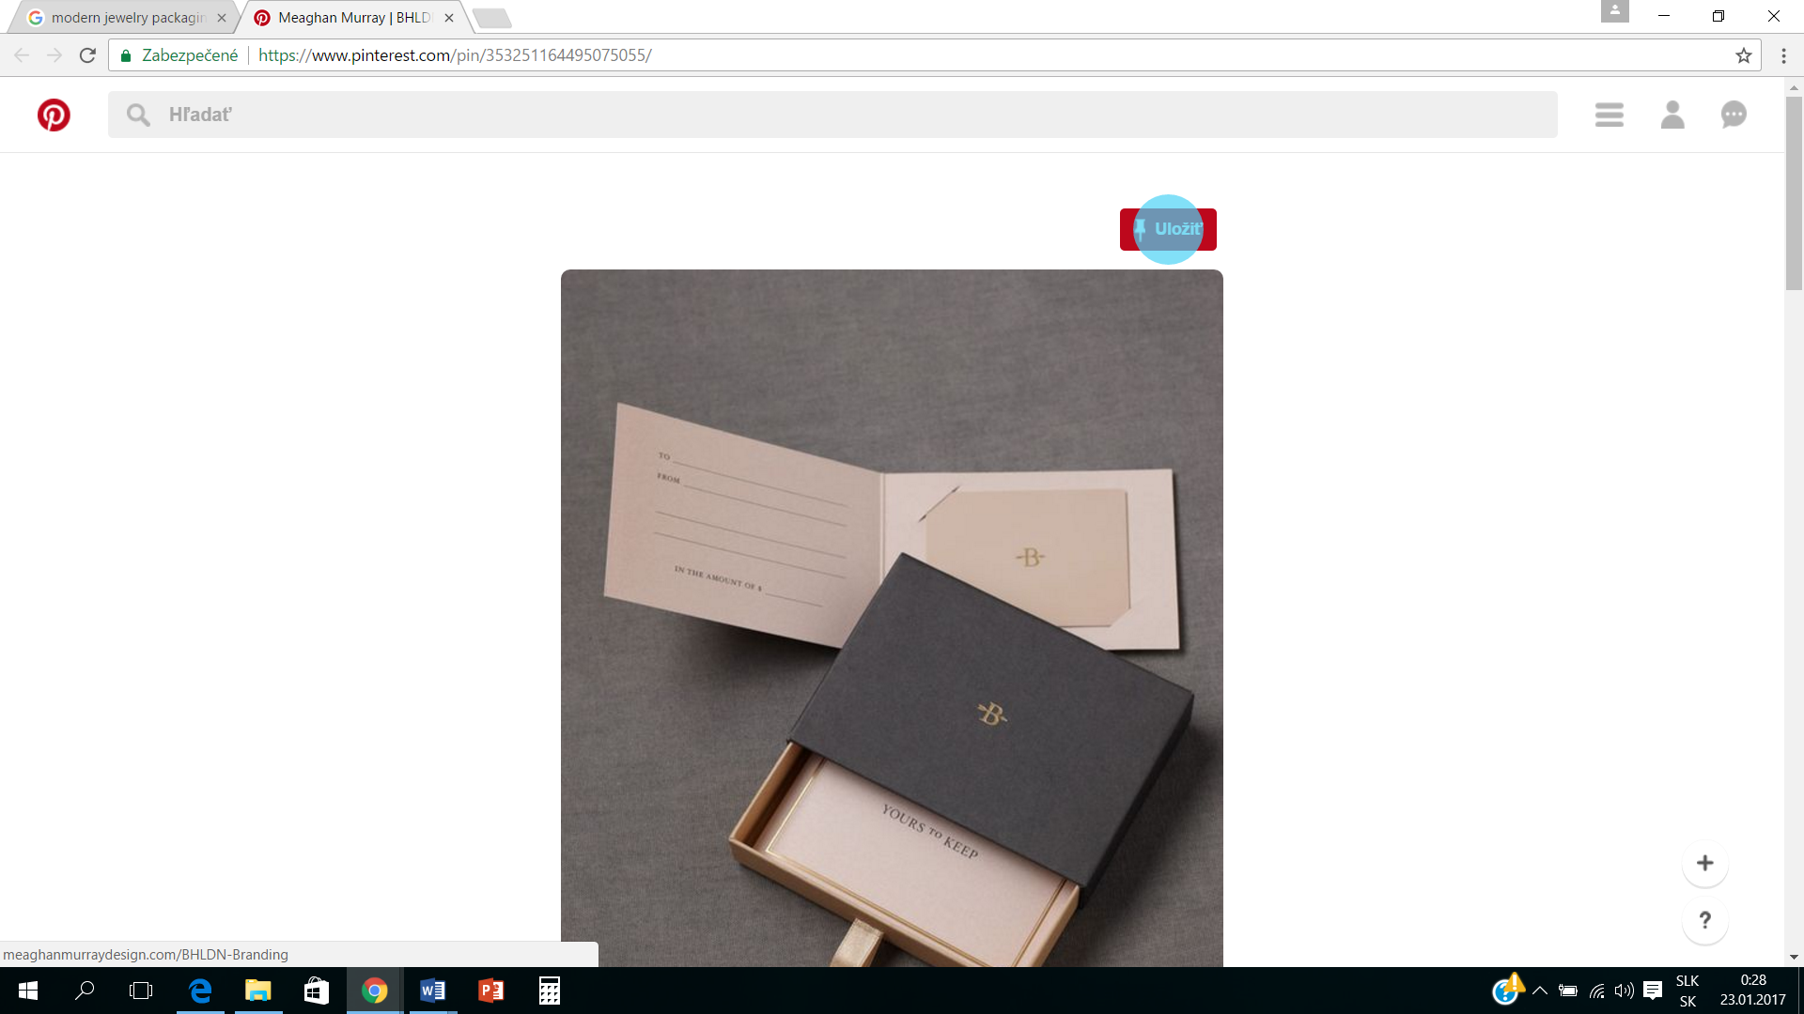

http://www.fsdpacking.com/product/modern-jewelry-gift-paper-box-braitain-fzh176_4689.html

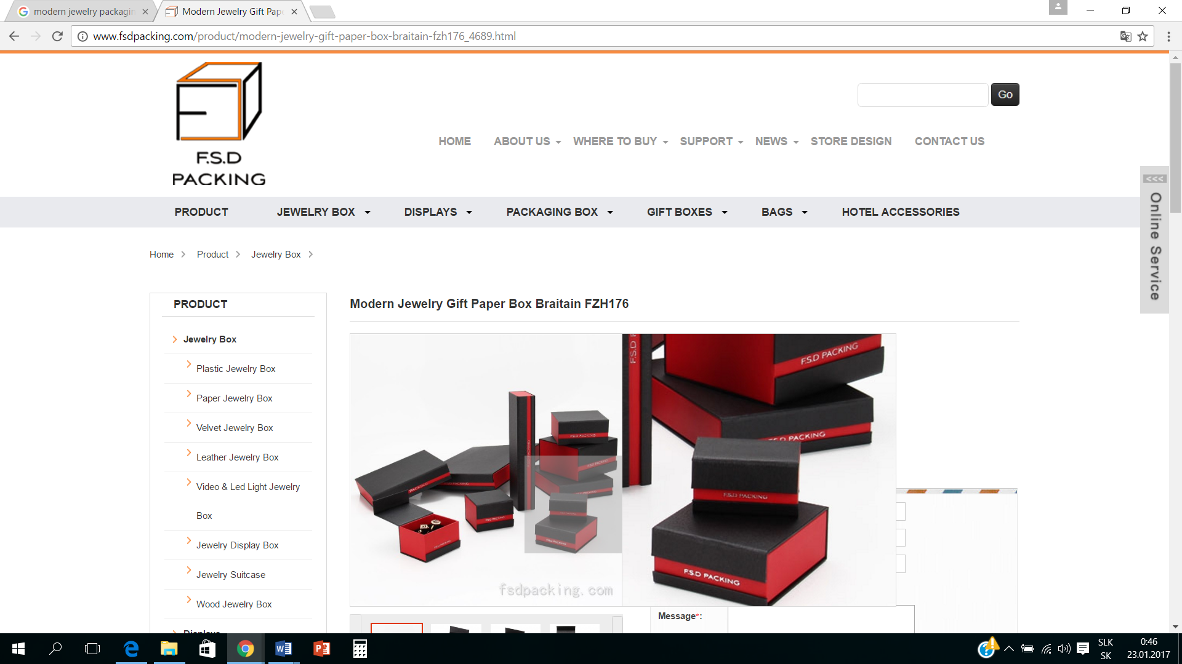

Vzor šperkov, ktoré budeme predávať.

